**MEDIA RELEASE**

***For immediate release***

Contact: Elliott Morgan

seedsedgemoor.com

Phone: 07983404 639

Email: Elliott@seedsedgemoor.com

**Somerset Rock Legend Jack Bessant to Headline Front Garden Music Festival 2025**

**Thu 29th May**

**It’s the Festival you don’t need to travel to, camp at or buy tickets for – its your very own front Garden Music Festival**

The much loved **Front Garden Music Festival** is returning for its **fifth year**, bringing another unmissable weekend of **free, live music** to the heart of Sedgemoor communities. On **Saturday 7 June**, **Victoria Park in Bridgwater** will be transformed into a hub of sound, celebration, and community spirit — the day features both local and visiting artists headlined by none other than **Somerset’s own Jack Bessant**, bassist of iconic rock band **Reef**, performing a set of blues infused Folk rock along with his band.

As ever, **entry is completely free**, and with activities like Cirque De Silk, face painting, interactive art workshops and more the festival promises something for everyone — from music lovers to young families.

Organised by **Seed Sedgemoor**, the Front Garden Music Festival champions **community-led creativity**, with all sites co-curated by local partners. Victoria Park is just one of several neighbourhood stages across Sedgemoor, bringing culture to everyone’s doorstep.

Seed Director Scott O’Hara said:

***Front Garden Music Festival is all about bringing people together through the power of music. We love the experience of creating something joyful and inclusive right on people’s doorsteps. In response to audience and local producer feedback, this year we are focusing on the very best local talent across the district. At Bridgwater’s Victoria Park this includes our festival headliner Jack Bessant  — and the fact that all the events are free makes it even more special. This is a celebration for everyone in the community. See you there!”***

Performances also take place at Ashcott, Cheddar, Edington and Highbridge. Bring your family, your friends, and your picnic blanket – and get ready for a weekend of unforgettable live music and community joy.

**What: Free outdoor music festival event**

**Where and When: Saturday 7th June**

**Victoria Park Bridgwater 12-5pm**

**Cheddar 2pm – 7pm**

**Ashcott 12 - 5:30**

**Sunday 8th June**

**Cheddar 2pm – 7pm**

**Edington 12:30 – 4:30**

**Highbridge 1pm – 5pm**

**IMAGES**

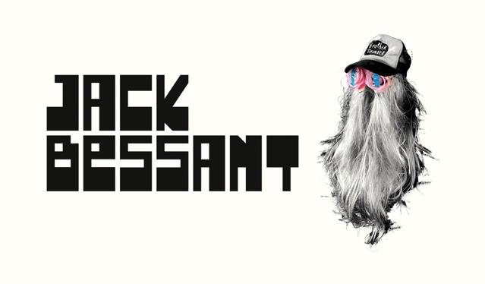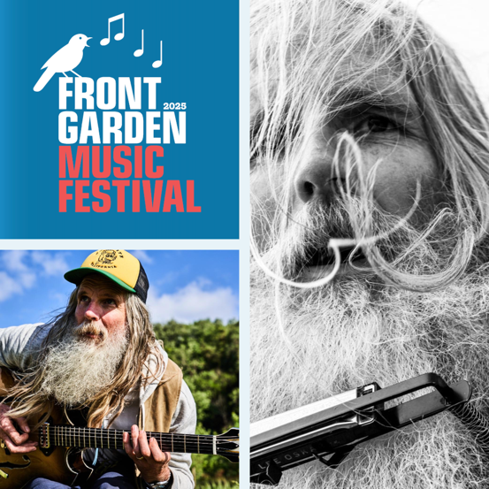

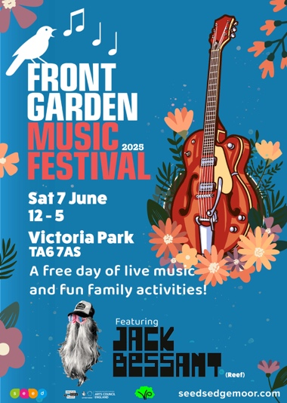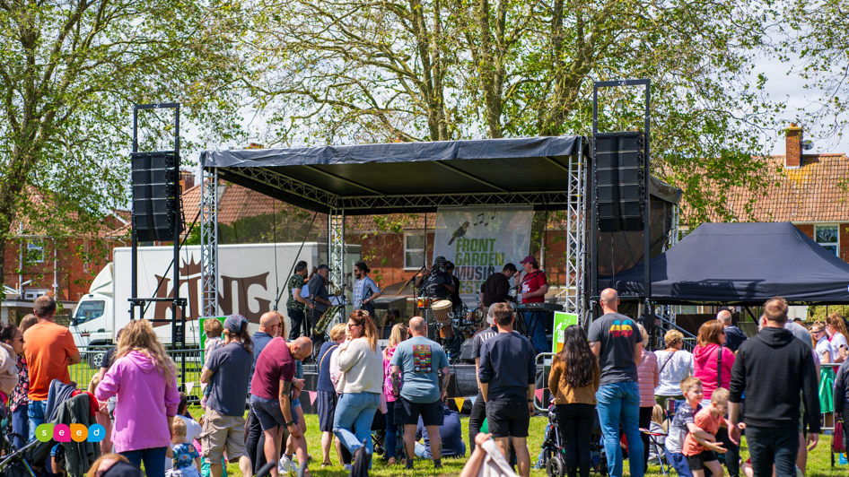

More images and full sizes here: <https://drive.google.com/drive/folders/1f4LKMUmSItu36Mov1ACqgufDBUgk0fYD>

——————————————————————————————————————

**Seed Sedgemoor**

The Engine Room | 52 High St. Bridgwater Somerset TA6 3BL info@seedsedgemoor.com | 01278 433187

**Seed** is a Consortium of local organisations comprising:

Homes in Sedgemoor,

Community Council for Somerset,

Bridgwater Senior Citizens Forum,

Our Highbridge

Somerset Film;

Young Somerset and

Bridgwater Town Council.

We believe that arts, culture and creativity are not elite activities, but should be an ordinary part of everyday life, created by, with and for the people. This can be achieved in partnerships with artists in all forms of the creative arts, working in response to the collective imagination and reflecting the things that are important to the communities of

Sedgemoor. We seek to make creative arts, culture and heritage part of everyday life in Sedgemoor by growing new opportunities for its people to participate, create and celebrate.

**Seed** is part of the Creative People and Places programme, supported using public funding by the National Lottery through Arts Council England. Thanks to National Lottery players, Creative People and Places is about more people taking the lead in choosing, creating and taking part in creative and cultural experiences in the places where they live.

Since 2012, there have been over 15 million engagements with the CPP programme and 90%[1] of people who participate in CPP weren’t previously engaging regularly with creativity and culture.

[Find out more about each project, the difference the programme has made and our learning >](https://www.artscouncil.org.uk/creative-people-and-places-0)

Average across 3 Audience Finder National Reports 2021/22, 2022/23 and 2023/24

#createyourplace

[www.creativepeopleplaces.org.uk](http://www.creativepeopleplaces.org.uk)

[www.artscouncil.org.uk/creative-people-and-places/creative-people-and-places-projects](http://www.artscouncil.org.uk/creative-people-and-places/creative-people-and-places-projects)

——————————————————————————————————————

**If you would like further information about Seed, this announcement or to arrange an interview please contact**

**Elliott Morgan**

**via** **elliott@seedsedgemoor.com or on ph. 07586 348372**

*/ends*

1.