**MEDIA RELEASE**

***For immediate release***

seedsedgemoor.com

Contact: Elliott Morgan

Phone: 07983404 639

Email: Elliott@seedsedgemoor.com

**The National Gallery arrive at Bridgwater**

**Fri 13th September**

Beginning September 26th, Art Road Trip will launch with a series of creative activities across Bridgwater, Burnham-on-Sea, and Cheddar. This exciting project, presented by The National Gallery and Seed, brings art and creativity directly to our community. The mobile creative studio will pop up at various locations offering free, fun, and inspiring workshops for all ages. Everyone is welcome to join!

Workshops will kick off at The Cornhill in Bridgwater, providing a hands-on opportunity to explore art in new and imaginative ways. Make sure to mark your calendars for this special chance to experiment with creativity and discover famous National Gallery artworks up close in a unique and playful setting. including*"Awe and Wonder"* a drop in workshop exploring landscapes using texture and light,*"Creating Your World"* a family friendly drop in where you can experiment with globe making and craft your piece of a collaborative installation. The team will also be offering talks themed on various artworks from the collection at The Creative Popup shop.

|  |
| --- |
|  |

Elisha Kenworth from the National Gallery said:

*"We’re thrilled to be coming to Bridgewater and excited to offer something for everyone in this dynamic community. From insightful talks to hands-on art workshops, our events are designed to engage and inspire. Whether you’re a seasoned artist, a curious beginner, or just looking for a creative outing with family, there’s an opportunity for you to explore, learn, and ignite your imagination. We can’t wait to spark new ideas and artistic passions with all of you!"*

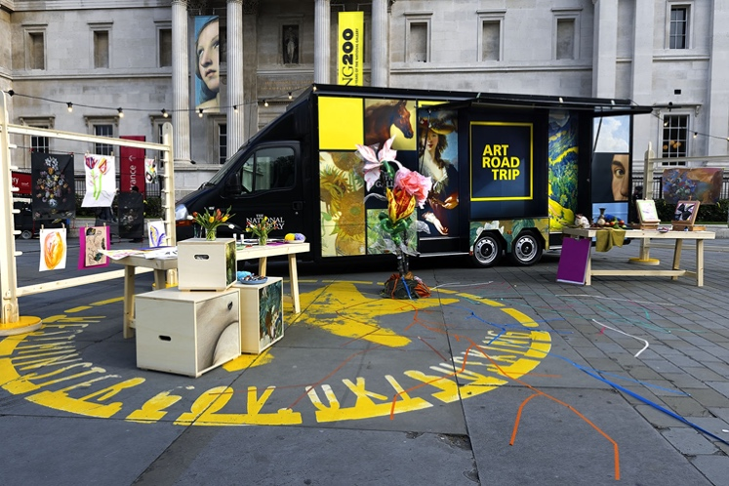

**Full Art Road Trip schedule:**

Thurs 26th Sept - **The Cornhill Bridgwater** 10am-4pm with additional Educational Talk at the Seed Creative Pop-up Shop in Angel Place 12.30 – 1pm  
Sat 28th Sept - **The Cornhill Bridgwater** 10am-4pm with additional Educational Talk at the Seed Creative Pop-up Shop in Angel Place 12.30 – 1pm  
Sun 29th Sept - **Burnham on Sea**, South Esplanade 10am-4pm  
Monday 30th Sept - **The Cornhill Bridgwater** 10am- 4pm with additional Educational Talk at the Seed Creative Pop-up Shop in Angel Place 12.30 – 1pm  
Thurs 3rd Oct - **The Cornhill** 10am-4pm with additional Educational Talk at the Seed Creative Pop-up Shop in Angel Place 12.30 – 1pm  
Sat 5th Oct - **The Cornhill** 10am-4pm with additional Educational Talk at the Seed Creative Pop-up Shop in Angel Place 12.30 – 1pm  
Sun 6th Oct - **Cheddar Gorge** 10am - 4pm  
Mon 7th Oct - **The Cornhill Bridgwater** 10am-4pm with additional Educational Talk at the Seed Creative Pop-up Shop in Angel Place 12.30 – 1pm

——————————————————————————————————————

**Seed Sedgemoor**

The Engine Room | 52 High St. Bridgwater Somerset TA6 3BL info@seedsedgemoor.com | 01278 433187

**Seed** is a Consortium of local organisations comprising:

Homes in Sedgemoor,

Community Council for Somerset,

Bridgwater Senior Citizens Forum,

Somerset Film; Young Somerset and

Bridgwater Town Council.

We believe that arts, culture and creativity are not elite activities, but should be an ordinary part of everyday life, created by, with and for the people. This can be achieved in partnerships with artists in all forms of the creative arts, working in response to the collective imagination and reflecting the things that are important to the communities of

Sedgemoor. We seek to make creative arts, culture and heritage part of everyday life in Sedgemoor by growing new opportunities for its people to participate, create and celebrate.

**Seed** is part of the Creative People and Places programme, supported using public funding by the National Lottery through Arts Council England. Thanks to National Lottery players, Creative People and Places is about more people taking the lead in choosing, creating and taking part in creative and cultural experiences in the places where they live.

Since 2012, there have been over 15 million engagements with the CPP programme and 90%[1] of people who participate in CPP weren’t previously engaging regularly with creativity and culture.

[Find out more about each project, the difference the programme has made and our learning >](https://www.artscouncil.org.uk/creative-people-and-places-0)

Average across 3 Audience Finder National Reports 2021/22, 2022/23 and 2023/24

#createyourplace

[www.creativepeopleplaces.org.uk](http://www.creativepeopleplaces.org.uk)

[www.artscouncil.org.uk/creative-people-and-places/creative-people-and-places-projects](http://www.artscouncil.org.uk/creative-people-and-places/creative-people-and-places-projects)

——————————————————————————————————————

**If you would like further information about Seed, this announcement or to arrange an interview please contact Scott O’Hara**

**via** **scott@seedsedgemoor.com or on ph. 07484 820672**

**interview please contact Elliott Morgan**

**via** **elliott@seedsedgemoor.com or on ph. 07586 348372**

*/ends*

1.