**MEDIA RELEASE**

 ***For immediate release***

Contact: Elliott Morgan

seedsedgemoor.com

Phone: 07983404 639

Email: Elliott@seedsedgemoor.com

**Mysterious Masterpieces appear in the Heart of Bridgwater**

**Mon 2nd December**

A new and exciting public art project, *Artscape*, is transforming the streets and spaces of Bridgwater into a vibrant gallery exhibiting some of the world’s most cherished masterpieces. This unique initiative is a collaboration between Seed, *Homes in Sedgemoor,* The National Gallery and local businesses, bringing framed full-scale high-quality replicas of timeless artworks to Bridgwater.

The project offers residents and visitors an extraordinary opportunity to engage with the works of artistic giants such as Van Gogh, Michelangelo, Gainsborough, and Turner, right in the heart of Bridgwater. The *Artscape* installations are strategically placed across the town, creating a tapestry of art around Bridgwater accessible to everyone.

Seed Director Scott O’Hara said:

***“We are always receiving feedback that art and creative activities make Bridgwater a better place to live, and our recent visit by the National Gallery’s Art Road Trip was very popular. We had the chance to hold on to some of the Gallery’s replicas and we thought why not put them in places where as many people as possible can see them. The initial response to Constable’s Haywain on the Angel Place bus stop, and Van Goghs Sunflowers on Bridgwater Post Office has been surprise, joy and an inspiration for us to do more.”***

Since then, Seed have installed more artworks as part of this *Artscape* project. Highlights include Bronzino’s *allegory with Venus and Cupid* at the rear exit of the Palace Nightclub, Van Eyck’s *Arnolfini Portrait* at Meads Court Community Hall, Turner’s *Fighting Temeraire* on the garages at West Bow House on West Street, and Gainsborough’s  *Mr. and Mrs. Andrews* at Dunwear House. Homes in Sedgemoor is the owner of three of these locations.

***“Artscape is a celebration of art and community, We’re thrilled to help bring these incredible works to Bridgwater, making art accessible to all and enriching the spaces around us.”***

*Claire tough Director of Communities and Customer Services at Homes in Sedgemoor*

Other sites will be installed soon including Claude’s *Embarkation of St. Ursula* at the Provender Mill by Bridgwater Docks*.* Each location offers an immersive cultural experience, blending art into everyday life

Seed is a charity and part of the Art’s Council’s Creative People and Places Programme, which was set up to bring free creative projects and activities to the most underserved part of the country in terms of arts and culture. Homes in Sedgemoor is the lead organisation on the Seed consortium.

**IMAGES**

Full size Images to accompany this release can be downloaded via:

[x](https://drive.google.com/drive/u/1/folders/1wTNnzFr6DZIXIHotAl7s6zbIE-XHiTFy)xxxxxxxxxxx

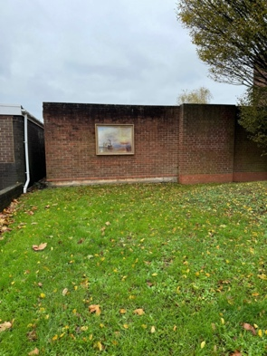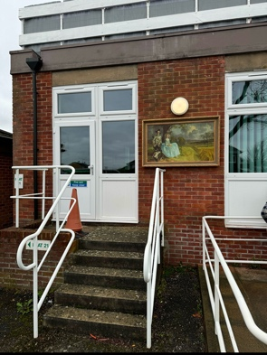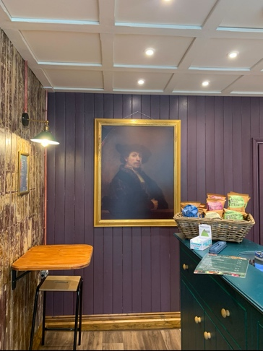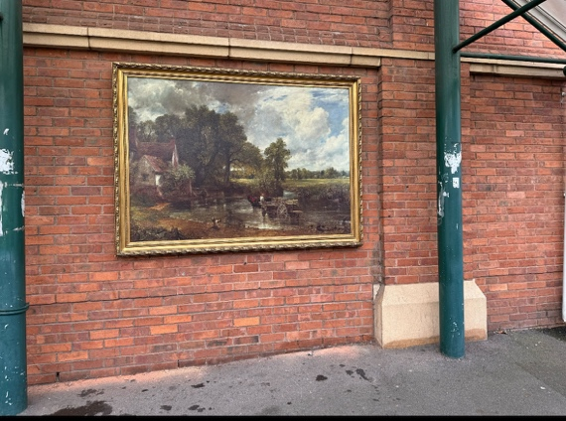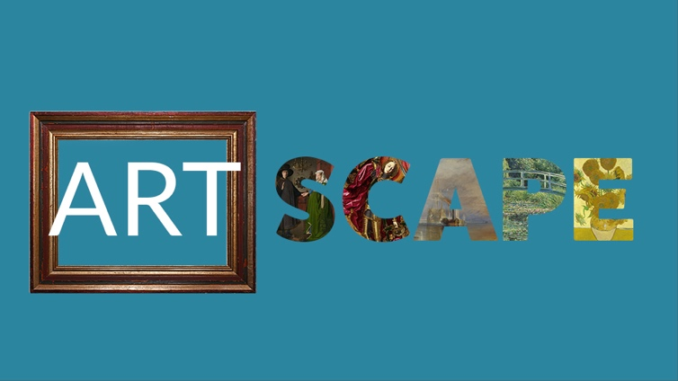

——————————————————————————————————————

**Seed Sedgemoor**

The Engine Room | 52 High St. Bridgwater Somerset TA6 3BL info@seedsedgemoor.com | 01278 433187

**Seed** is a Consortium of local organisations comprising:

Homes in Sedgemoor,

Community Council for Somerset,

Bridgwater Senior Citizens Forum,

Somerset Film;

Young Somerset and

Bridgwater Town Council.

We believe that arts, culture and creativity are not elite activities, but should be an ordinary part of everyday life, created by, with and for the people. This can be achieved in partnerships with artists in all forms of the creative arts, working in response to the collective imagination and reflecting the things that are important to the communities of

Sedgemoor. We seek to make creative arts, culture and heritage part of everyday life in Sedgemoor by growing new opportunities for its people to participate, create and celebrate.

**Seed** is part of the Creative People and Places programme, supported using public funding by the National Lottery through Arts Council England. Thanks to National Lottery players, Creative People and Places is about more people taking the lead in choosing, creating and taking part in creative and cultural experiences in the places where they live.

Since 2012, there have been over 15 million engagements with the CPP programme and 90%[1] of people who participate in CPP weren’t previously engaging regularly with creativity and culture.

[Find out more about each project, the difference the programme has made and our learning >](https://www.artscouncil.org.uk/creative-people-and-places-0)

Average across 3 Audience Finder National Reports 2021/22, 2022/23 and 2023/24

#createyourplace

[www.creativepeopleplaces.org.uk](http://www.creativepeopleplaces.org.uk)

[www.artscouncil.org.uk/creative-people-and-places/creative-people-and-places-projects](http://www.artscouncil.org.uk/creative-people-and-places/creative-people-and-places-projects)

——————————————————————————————————————

**If you would like further information about Seed, this announcement or to arrange an interview please contact**

**Elliott Morgan**

**via** **elliott@seedsedgemoor.com or on ph. 07586 348372**

*/ends*

1.