**MEDIA RELEASE**

***For immediate release***

seedsedgemoor.com

Contact: Elliott Morgan

Phone: 07983 404639

Email: Elliott@seedsedgemoor.com

**Can you help to make Bridgwater more creative?**

23/11/2023

**Seed, the Creative People and Places project for Sedgemoor, is inviting everyone in Bridgwater to Creative Accelerator events in December and January.**

A creative accelerator is an open conversation event where residents can talk directly to Seed about what they would like to see happen creatively in their area. It is an opportunity for members of the community to create and shape activities in Bridgwater.

Past projects that have come from creative accelerators include **The Front Garden Music Festival,** **Blues in the Pews** in Highbridge and the **Cheddar individuality project**.

This is a fantastic opportunity for the people of Bridgwater to make their ideas a reality. **Creative Accelerators** are free, open to everyone and are designed in a way that each individual will have the chance to be heard.

As part of the [Art’s Council’s Creative People and Places Programme](https://www.artscouncil.org.uk/creative-people-and-places-0) **Seed** has the budget specifically to bring these ideas and thoughts into reality, building and shaping their programme in Bridgwater for the next 18 months. This will include an artist call out for proposals for commission as well as events curated and produced by Seed.

**The next Creative Accelerator event takes place at Victoria Park Community Centre café**

**December 14th 6pm – 8pm**

*“These sessions are different to your usual consultation events” says Seed Director, Scott O’Hara, “because they are the first step in enabling local people to actually decide in how the grant funding we receive from Arts Council England should be spent. We have the money to make things happen. We want to look past what is currently available and find out what you would like to see happen. From experience we know that it doesn’t take long for people to start getting creative! We will then continue to work with members of the community to make the best ideas a reality.*

**How it works**

Seed gathers members of the community in a relaxed environment and start the conversation with prompts such as ***‘what would you like to see more of?’*** or ***what events have you seen elsewhere that you liked the look of?***To get people’s ideas flowing. No one is pressured to speak, yet everyone is given the chance to speak and no idea is too big or small. Ideas can be as simple as ‘more live music’ to ‘crafting clubs to help wellbeing’ or even a music festival.

*"I came along this week to the Creative Accelerator group at the Engine Room and went home on such a high! I absolutely loved having the opportunity to think creatively and can see what incredible work Seed Sedgemoor is doing, it really was a thrill to be a part of that”*

Jo Middleton

Bridgwater Resident

A full archive of all past Seed projects can be found here

<https://seedsedgemoor.com/previous-opportunities/>

A video on the Front Garden Music Festival can be found here

<https://youtu.be/wz7NdTV11fY>

More info on

[Blues in The Pews](https://seedsedgemoor.com/activities/blues-in-the-pews/) and [Cheddar Individuality Project](https://seedsedgemoor.com/activities/cheddar-individuality-project-come-home/) both originated from Creative Accelerators

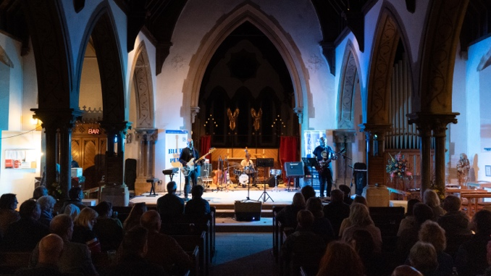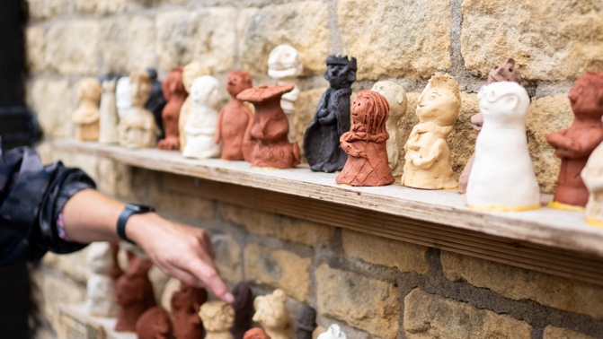

**Don’t forget to sign up to the**[**Seed Ebulletin**](https://seedsedgemoor.com/sign-up-to-our-ebulletin/) **and follow us on Socials to be the first to know when more info is announced!**

Seed Sedgemoor

The Engine Room | 52 High St. Bridgwater Somerset TA6 3BL info@seedsedgemoor.com | 01278 433187

Seed is a Consortium of local organisations comprising:

Homes in Sedgemoor,

Community Council for Somerset,

Bridgwater Senior Citizens Forum,

Somerset Film; Young Somerset and

Bridgwater Town Council.

We believe that arts, culture and creativity are not elite activities, but should be an ordinary part of everyday life, created by, with and for the people. This can be achieved in partnerships with artists in all forms of the creative arts, working in response to the collective imagination and reflecting the things that are important to the communities of Sedgemoor. We seek to make creative arts, culture and heritage part of everyday life in Sedgemoor by growing new opportunities for its people to participate, create and celebrate.

[www.creativepeopleplaces.org.uk](http://www.creativepeopleplaces.org.uk)

[www.artscouncil.org.uk/creative-people-and-places/creative-people-and-places-projects](http://www.artscouncil.org.uk/creative-people-and-places/creative-people-and-places-projects)

——————————————————————————————————————

If you would like further information about Seed, this announcement or to arrange an interview please contact Elliott Morgan

via Elliott@seedsedgemoor.com or on ph. 07983404639

*/ends*